

**K J Somaiya College of Engineering, Mumbai-77**

**(Autonomous College Affiliated to University of Mumbai)**

Batch: D2 Roll No.:16010221038 Name: Eshan Kalp Trivedi

Experiment / assignment / tutorial No.

Grade: AA / AB / BB / BC / CC / CD /DD

Signature of the Staff In-charge with date

**Title**: Bell Crank Lever

**CO1** Identify the effect of forces and moment in a given engineering system

**Objective**

To verify the principle of Moments using Bell Crank Lever.

**Theory**

Principle of moments states that, ‘the algebraic sum of moments of a system of coplanar forces about any point in the plane is equal to the moment of the resultant of a force of the system about the same point’.

This principle would be verified for a bell crank lever arrangement.

A lever whose two arms form a right angle and having its fulcrum at the apex of the angle is known as bell crank lever. These levers were initially used to operate the bell from a long distance especially where change in the direction of bell wires was involved and hence the name.

**AIM:**

To verify the condition of equilibrium of a coplanar concurrent system of forces and to find the error if any.

**APPARATUS:**

Bell crank Lever apparatus, weights, hangers and scale.



**K J Somaiya College of Engineering, Mumbai-77**

**(Autonomous College Affiliated to University of Mumbai)**

**Setup Diagram:**

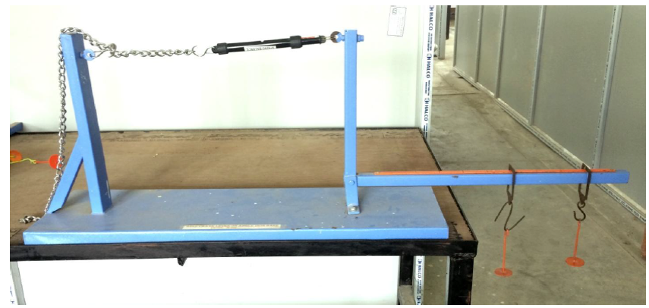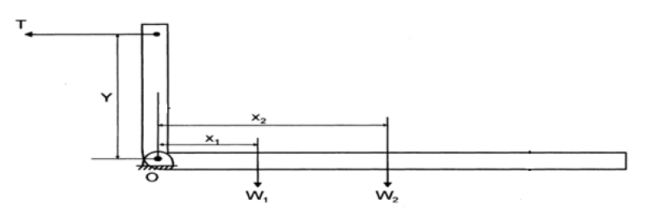

**PROCEDURE:**

1. Arrange hanger at arbitrary location on the horizontal arm. Note the location X from the hinge. Adjust the tension in the spring connected to the vertical arm such that the two pointers come in the same vertical line. In this position the horizontal arm is truly horizontal. Note the initial spring balance reading T1. Also note the location of the spring from the hinge.
2. Hang the weight W from the hanger. This will cause the arms to tilt and the pointers to move away from each other. Now adjust the tension in the spring such that the pointers once again come in the same vertical line. The horizontal arm is once again in its horizontal position. Note down the final spring balance reading T2. The tensile force on the vertical arm is the difference T2-T1.
3. Since the external force is supported by the single hinge at the apex of the arm, implies that the resultant of these forces passes through the hinge. Therefore to verify the principle of the moments we need to take moments of all the forces about hinge and if the total sum is zero, verifies the law of moments since the moment of the resultant is also zero at the hinge.
4. Repeat the above steps by changing the weights and their location in the horizontal arm.



**K J Somaiya College of Engineering, Mumbai-77**

**(Autonomous College Affiliated to University of Mumbai)**

**OBSERVATION TABLE:**

|  |  |  |  |  |  |  |  |  |  |  |
| --- | --- | --- | --- | --- | --- | --- | --- | --- | --- | --- |
| Sr  No | Weig  ht  (W)  Kg | Distan ce from fulcru m (X cm) | M1  =  W  X Kg cm | Reading of Spring balance | | Effo  rt  T= (  T2-  T1) kg | Distan ce Y  cm | M2  = T  *Y | M1  -  M2 | %  Error |
| Initi al  T1 | Fina l T2 |
| 1 | 1 | 25 | 25 | 0 | 1.225 | 1.225 | 21 | 25.725 | -0.725 | 2.9% |
| 2 | 1 | 40 | 40 | 0 | 1.935 | 1.935 | 21 | 40.635 | -0.635 | 1.5% |
| 3 | 1 | 65 | 65 | 0 | 3.61 | 3.61 | 21 | 75.81 | -10.81 | 16.6% |

**CALCULATION:**

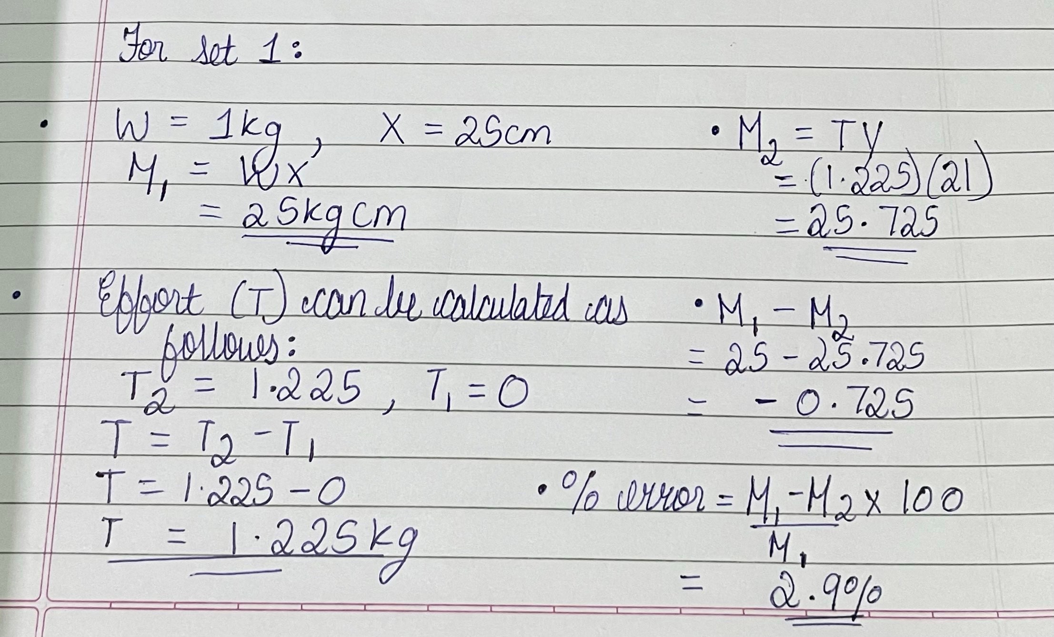

**RESULT:**

**M1-M2= -0.725 for set 1**

**%ERROR= 2.9% for set 1**

**CONCLUSION:**

We observe that while the principle of moments is verified there is a difference in the experimental and observed values of the moment of force in the experiment. The reasons for the same are as follows:

1. There can be error in the pointer arrangement and thus the horizontal arm may not be perfectly horizontal.
2. The screw for tightening the chain may not be tightly fixed due to chain there may not be sufficient tension in the chain.
3. There can be measurement error while measuring spring balance due to parallax errors.
4. The hinged support is not completely frictionless thus some force may be lost to overcome frictional resistance.

# Signature of faculty in-charge